Congratulations Daniel Lobo

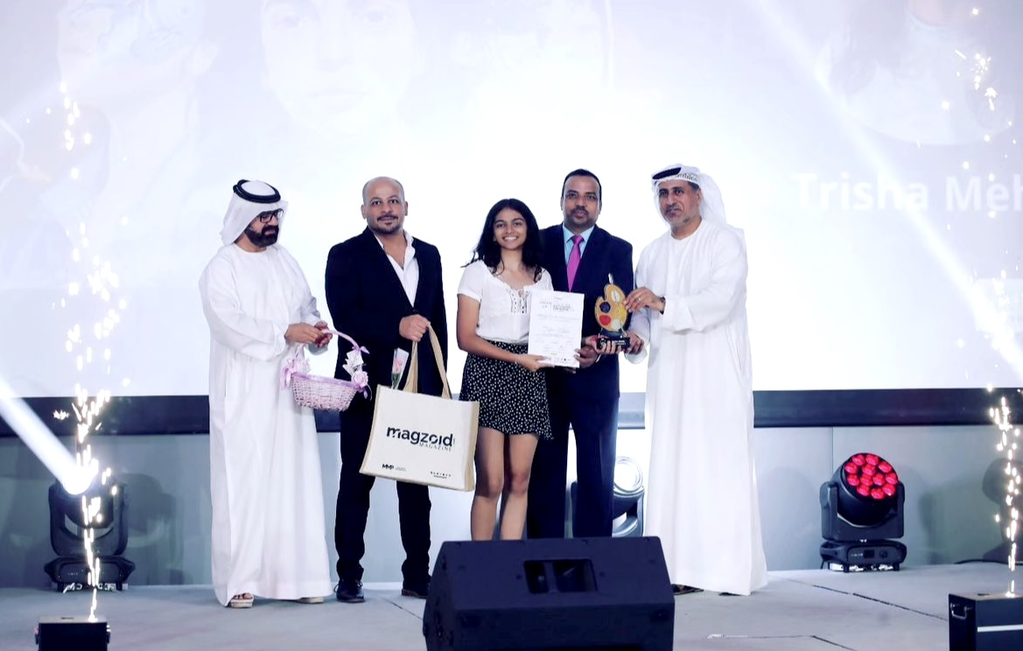Trisha Mehta Wins First Prize at CREATE 2.0 Art Competition!

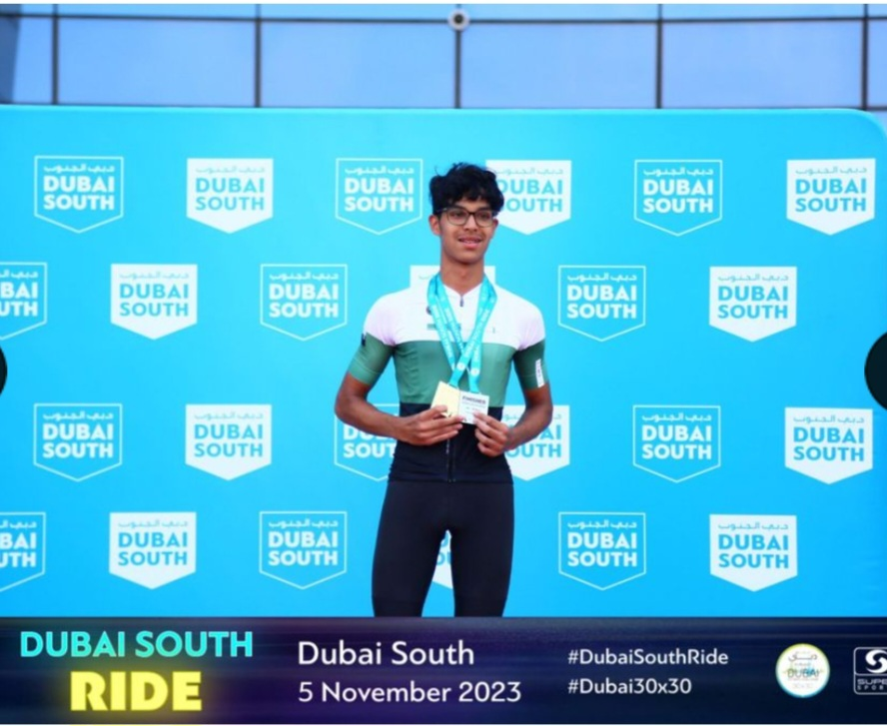

Daniel Lobo -2023
Daniel Lobo, our year 11 student, participated in the Dubai South Ride- 40km on 5th Nov 2023.
He completed the 40km route in 1hr 17minutes and came First in the 16-18 age group.
Overall, he came 38th out of 145 cyclists and was the youngest cyclist among all the riders!
Congratulations on your achievement.

